RELATED WORK

One recent active field of research that contributes to short sentence automatic grading is sentence similarity. A research work done by Egyptian research group claims that the methodology they have used is the best for any unsupervised technique for short answer grading [1]. Firstly, preprocessing was done using natural language processing methods such as raw, stop, stem and stopstem. Next they have considered string based similarity as well as corpus based similarity separately and used the similarity score gained to evaluate the students answer. For string based similarity, thirteen well known algorithms (Damerau-Levenshtein, Jaro, Jaro–Winkler, N-gram, etc.) were used. In order to use the corpus based similarity, Latent Semantic Analysis (LSA) was used with Wikipedia corpus. It is also not enough to solve our problem since this research work also focused on text similarity.

Different semantic similarity measures were compared including Knowledge-based and Corpus-based algorithms [2, 3]. The research group has first worked on unsupervised techniques only using knowledge-based measures and corpus-based measures with WordNet hierarchy and Wikipedia corpus [2]. Then they have tried machine learning algorithm perceptron to improve their results [3]. They have also implemented a novel technique to improve the similarity score of low scoring answers. Firstly similarity scores were ranked from most similar to least. Secondly, the words of the top N ranked answers were then added to the gold standard answer (New model answer). The remaining answers were then rescored according the new gold standard vector. Finally, the second-run scores for the remaining answers were multiplied by highest-scoring answer of the first-run N answers to give lower similarity score than first set of N answers. A research done by Li focused on Sentence similarity based on semantic nets and corpus statistics [4]. First they forms a joint vector from the words of the two sentences which are to be compared. Then they forms two vectors for each sentences by employing WordNet for word to word comparison. Similarly they also forms word order vector to take the word ordering in to the similarity calculation. WordNet is still under implementation for Sinhala language, so we are unable to test their approach.

Methodology

Label Validation Module:

In Venn diagram grading, to offer marks for a particular diagram, labels should be identified properly. These labels are written in Sinhala language and it can be a single word or a short phrase. Fig. 1 shows the flow chart of the label validation module. First, it checks if the labels in the student’s answer directly matches with one of the labels found in the model answer labels. If it matches, system evaluates student label as correct. If not, using the question and the labels provided in the model, this module forms a word joint vector (Bag of words). Then Similarity matrix is formed using model answer labels and the student answer label. Next System calculate cosine similarity between each column vectors in the matrix. Finally it selects the maximum similarity value and the relevant model answer and it calculates the Levenshtein (edit) distance (LD-min). Then it will calculate the maximum edit distance (LD-max) between the selected label and the label in the student’s answer. Finally it checks whether minimum edit distance is less than or equal to the maximum edit distance between student unit and the selected unit multiplied by a tolerance value (Tval). Using the training data collection, the tolerance value is tuned to be 0.51.

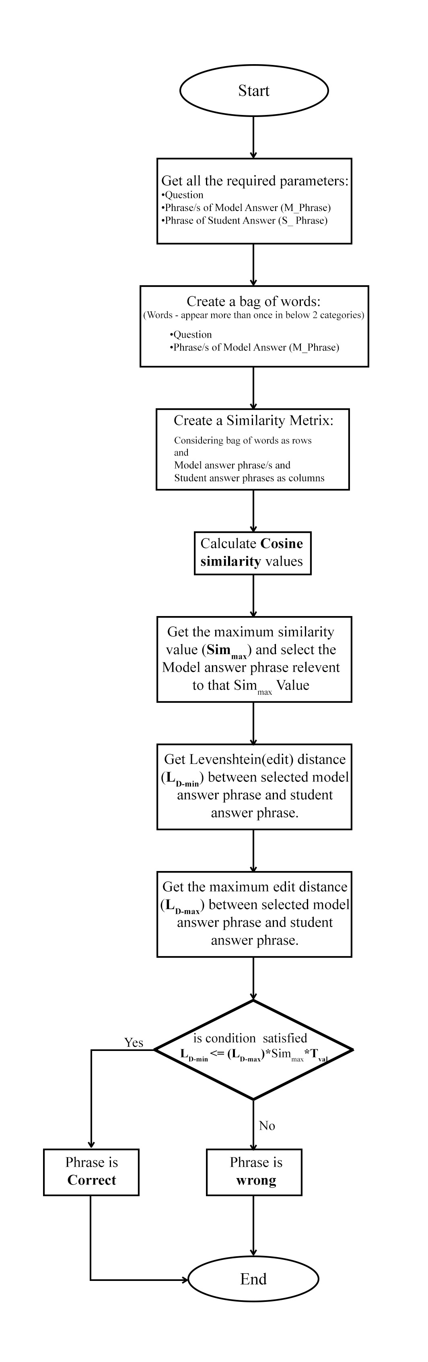

[1]. Wael H. Gomaa (2013). Short Answer Grading Using String Similarity And Corpus-Based Similarity, Modern Academy for Computer Science & Management Technology, Cairo, Egypt.

[2]. Michael Mohler (2009). Text-to-text Semantic Similarity for Automatic Short Answer Grading, Department of Computer Science, University of North Texas.

[3]. M. Mohler (2011). Learning to Grade Short Answer Questions using Semantic Similarity Measures and Dependency Graph Alignments, Department of Computer Science, University of North Texas.

[4]. Li, Yuhua, et al. "Sentence similarity based on semantic nets and corpus statistics." IEEE transactions on knowledge and data engineering 18.8 (2006): 1138-1150.